Resistivity and Resistance

Apparatus
reels of copper and other wires of known length and diameter (for example complete reels of enameled copper wire in standard lengths), ohm-meter
Note – the reels need to be fairly long (several meters or more) to have substantial resistances, and if using enameled copper wire the wire may need to be sanded at the ends to expose the copper so that a probe can make electrical contact.

Action
The students measure the resistance of the lengths of wire. They should examine the effect of length, cross section and material on both the resistance and the resistivity, and distinguish between resistance and resistivity.

The Physics
Resistance increases with length, and decreases with cross section for a given material. Resistivity is a property of the material, and does not depend on shape or size.
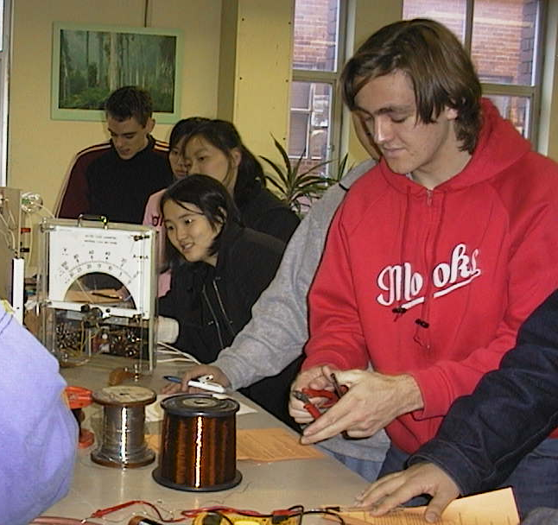

Optometry students at the University of New South Wales preparing to measure the resistance of various types of wire.

Accompanying sheet

Resistivity and Resistance

Measure the resistance of the objects displayed.

How does the length of the object affect its resistance?
How does it affect resistivity?

Does the shape or size of its cross section have an affect?

