Workshop Tutorials for Introductory Physics
EI8: Electromagnetism

A. Review of Basic Ideas:

Use the following words to fill in the blanks:
right, electricity, Faraday’s, currents, changing, thumb, induction, circles

Currents and fields
There is a relationship between ________ and magnetism, which was discovered by Hans Christian Oersted in 1819. During a lecture demonstration he noticed that a wire carrying an electric current deflected the needle in a nearby compass. Not only are magnetic fields produced by permanent magnets, but they are also produced by moving charges, or ________.
For example, the magnetic field lines produced by a current I in a long straight wire form _______ around the wire and the magnitude of the field at a distance r from the axis of the wire is given by $B=\frac{μ_{0}I}{2πr}$. The constant μ₀ is the permeability of free space, and is equal to 4π × 10⁷ N.A⁻². You can use your _______ hand to find the direction of the field. Point your _______ in the direction of the current and your fingers curl in the direction of the field. The field is _________ to the current that produced it.
It turns out that not only do currents produce a magnetic field, but a _________ magnetic field produces a current. This effect is called electromagnetic _________, because the changing magnetic field induces an electric field which can cause a current in a conductor. Such an induced current also produces a magnetic field whose net effect is to oppose the change that produced the current in the first place. This is Lenz’s law.
The induced electric field exists even if there is no conductor and no induced current. Such induced electric fields are often described in terms of an associated quantity called emf. In a closed conducting loop such as a coil of wire with resistance R the induced emf and the induced current are related by emf = IR. We can find the emf induced in a closed loop of area A, using ________ law : emf = $−\frac{dΦ}{\text{dt}}$, where Φ is the magnetic flux through the loop. In the simple case of a uniform field perpendicular to the plane of the loop, the flux is given by Φ = BA.

Discussion Question:
You can induce an emf by changing the size of the magnetic field though a loop. How else could you induce an emf?

B. Activity Questions:

The magnetic force - pinch effect
Turn on the power supply and observe what happens to the wires.
Draw a diagram showing the fields, currents and forces on the wires.
How can you make the wires repel instead of attracting?

- Electromagnetic Induction – two coils of wire and a magnet
If a magnet is moved into and out of a closed loop of wire, a current is induced in the loop of wire.
How do the direction and magnitude of the current depend on the motion of the magnet?
What happens if the magnet is reversed?
What happens if the loop is moved and the magnet is stationary?
Will a similar phenomenon be observed if a current carrying coil of wire moves relative to a loop of wire?

- Magnetic braking I – pendulums
Allow the pendulums to swing between the magnets.
Which pendulums swing and which stop? Why?

- Magnetic braking II – magnets in pipes
Drop the magnet down the pipes.
Why do magnets take longer falling down a copper pipe than free falling?
What is happening in the copper pipe with the slit?

C. Qualitative Questions:

1. Almost all electricity production uses a generator. Coal and nuclear power stations use steam and hydroelectric stations use liquid water to drive a turbine which runs the generator. Even cars use a generator to charge the battery while the engine is running.
- Draw a diagram showing the main components of a generator.
- Referring to your diagram, explain how a generator works.
- Why do generators produce an alternating current (AC) rather than a direct current (DC)?
2. Two circular loops lie adjacent to each other. One is connected to a source that supplies a current; the other is a simple closed ring. The current in the first loop travels clockwise. The loops can be arranged so that they stand parallel to each other (arrangement I) or next to each other (arrangement II).
a. Would you expect a difference in the induced current when the power supply is turned on in the two arrangements? Explain why or why not.
b. Sketch a graph of the current as a function of time when the power supply is turned on and then off again.

D. Quantitative Question:

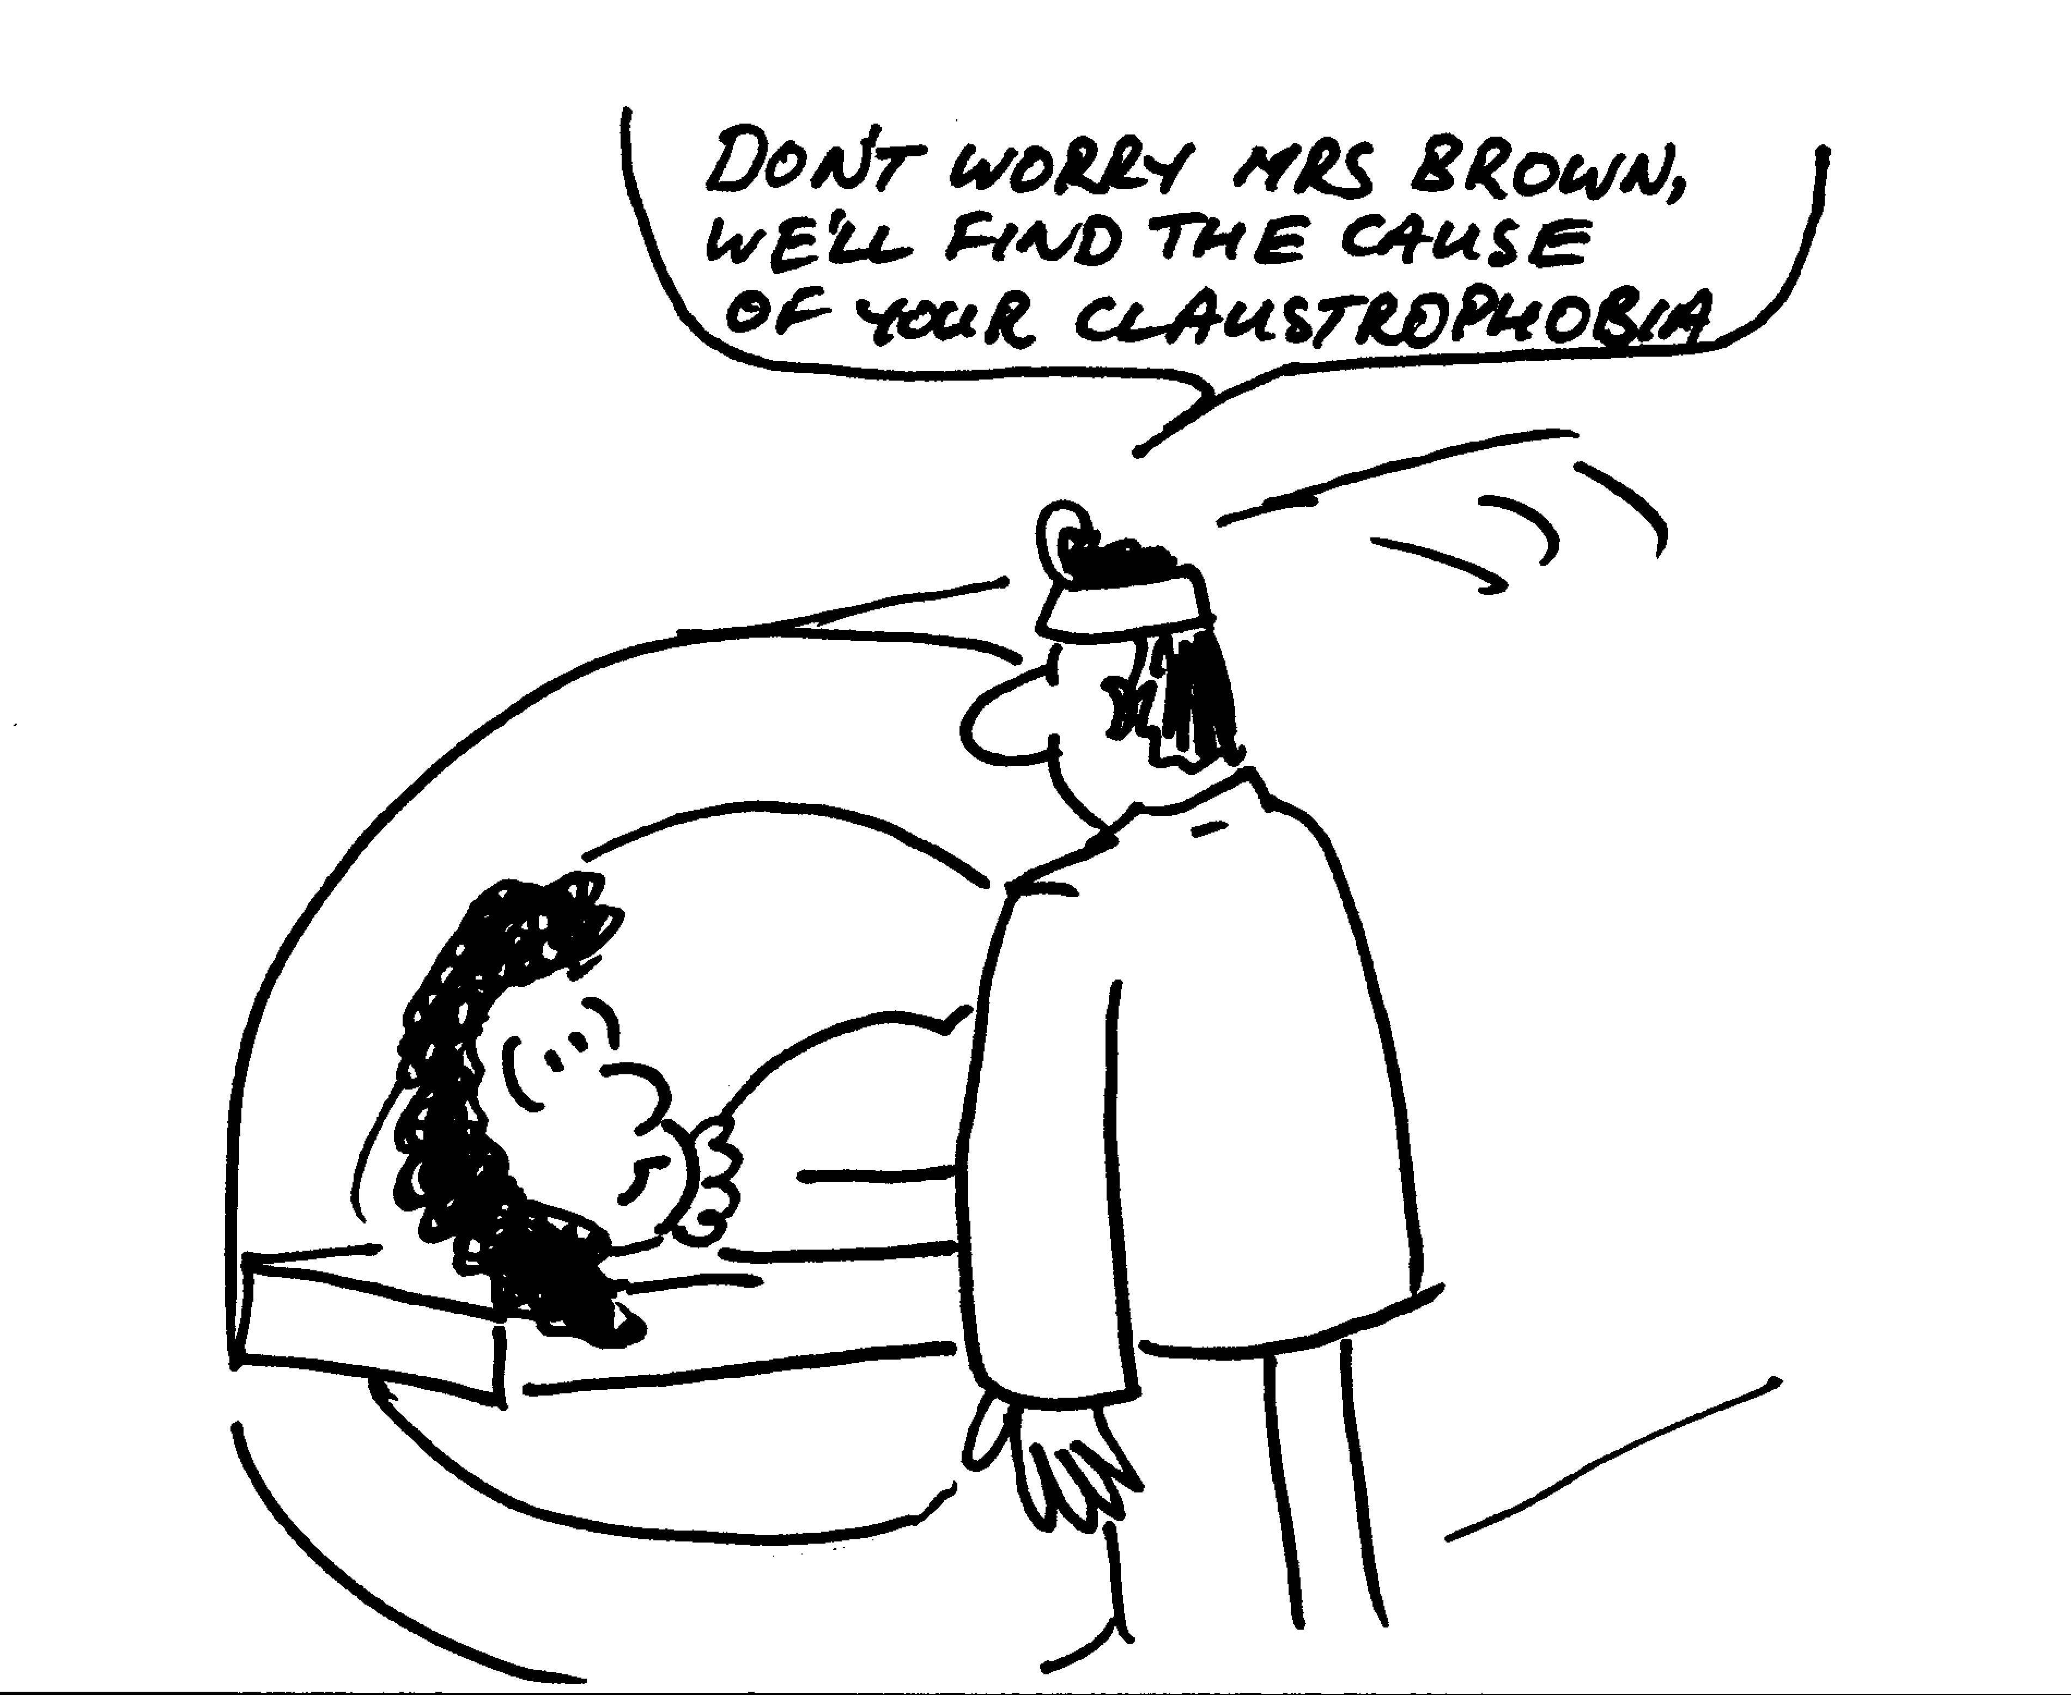
Magnetic resonance imaging (MRI) is used to produce images of the interior of the body, especially the brain. The patient is strapped down tightly to a flat stretcher which then slides into the scanner. The scanner produces a strong variable magnetic field.
- Why are patients asked to remove all jewelry and any clothing with zips or metal buttons or clips?
The human body can be described as a bag of salt water, because it contains a great deal of fluid with dissolved ions. A woman is in an MRI scanner which can produce a field of 1.5 T. The largest surface area through which magnetic flux passes is 0.04 m² with a normal parallel to the direction of the field.
- If the maximum average induced emf is to be kept less than 0.01 V, how long must it take for the machine be powered down from maximum field to zero?

